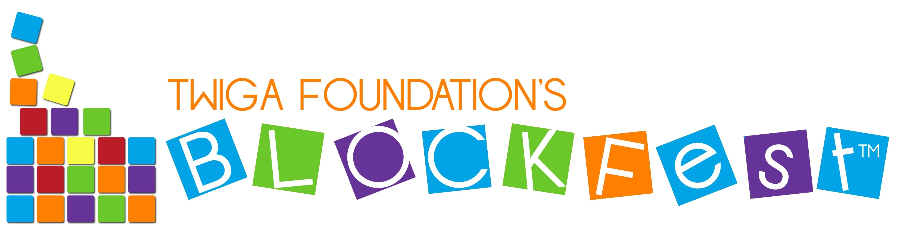 |  |  |  |  |  |  |  | Event Summary
Completed by: |  |  |  |  |  | Date:
(Host) |  |  |  |  |  | City, ST:
Using Sub-License#
Host Organization: |  |  |  |  |  | Event Name:
 |  |  |  |  |  | Address:
Contact:
Phone: |  |  |  |  |  | City, ST:
email: |  |  |  |  |  | Zip:
Number of  1-Hr Sessions | Number of  Adults |  | Number of Children |  | English/Spanish Parent Handbooks |  |  |  |  | Parent Feedback Cards NUMBER COLLECTED
Number of  1-Hr Sessions |  |  |  |  | GIVEN |  | SOLD |  |  | Parent Feedback Cards NUMBER COLLECTED
Number of  Hosts: |  | # |  |  | Number of  Volunteers: |  |  |  | #
Donations  Received: | $ |  |  |  | In-Kind Donations  Received:
TOTALS | Total dollar amount collected from admissions: |  |  |  |  |  |  |  | $
TOTALS | Total dollar amount collected from renting exhibit: |  |  |  |  |  |  |  | $
TOTALS | Total dollar amount collected from fees charged for conducting training: |  |  |  |  |  |  |  | $
TOTALS | Total number of Parent Handbooks SOLD: |  |  |  |  |  |  |  | #
TOTALS | Total dollar amount from Parent Handbook Sales: |  |  |  |  |  |  |  | $ **
TOTALS | ** x 5% = |  |  | TOTAL 5% royalties due Twiga on Sales: |  |  |  |  | $
01/2017

 |  |  |  |  |  |  |  |  | Event Summary
Completed by: |  |  |  |  |  |  | Date:
(Host) |  |  |  |  |  |  | City, ST:
Using Sub-License #
Host Organization: |  |  |  |  |  |  | Event Name:
 |  |  |  |  |  |  | Address:
Contact:
Phone: |  |  |  |  |  |  | City, ST:
email: |  |  |  |  |  |  | Zip:
Number of  1-Hr Sessions | Number of  Adults |  | Number of Children |  |  | English/Spanish Parent Handbooks |  |  |  |  | Parent Feedback Cards NUMBER COLLECTED
Number of  1-Hr Sessions |  |  |  |  |  | GIVEN |  | SOLD |  |  | Parent Feedback Cards NUMBER COLLECTED
Number of  Hosts: |  | # |  | Number of  Volunteers: |  |  |  |  |  | #
Donations  Received: | $ |  |  | In-Kind Donations  Received:
TOTALS | Total dollar amount collected from admissions: |  |  |  |  |  |  |  |  | $
TOTALS | Total dollar amount collected from renting exhibit: |  |  |  |  |  |  |  |  | $
TOTALS | Total dollar amount collected from fees charged for conducting training: |  |  |  |  |  |  |  |  | $
TOTALS | Total number of Parent Handbooks SOLD: |  |  |  |  |  |  |  |  | #
TOTALS | Total dollar amount from Parent Handbook Sales: |  |  |  |  |  |  |  |  | $ **
TOTALS | ** x 5% = |  |  |  | TOTAL 5% royalties due Twiga on Sales: |  |  |  |  | $
01/2017

